Milestone report: Milesatone 2-Create q quiz

There are many things I experimented with and implemented on my webpage to include java script and HTML elements correctly. Some things include making the text green or red after the user submits the quiz to show what questions were correct. I also added functions, elements and events based on users actions such as clearing form and displaying results and etc.
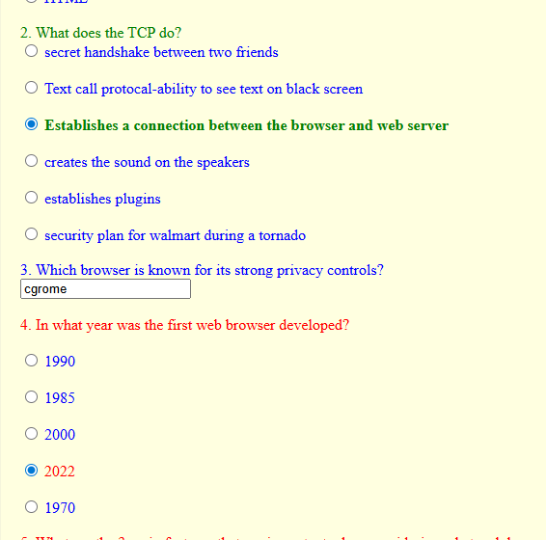
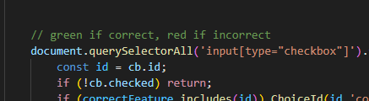

- I did create the quiz on a separate page and added it to the main menu/navigation bar to other pages on the site.
From home page:
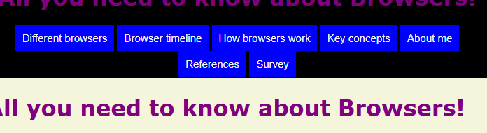
Also in code it is coded to show on a different page not embedded in another page.
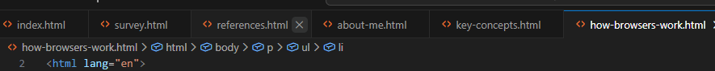

- I have a total of 7 questions that include 4 multiple choice (radios) questions and 2 fill in the blank and 1 multiple checkbox question,
- I used margins and color formatting to show quiz in a easy flow design.

- When the user is done with the quiz, they can submit it and it will show the score in fraction format of questions correct and incorrect. It will also display a PASS/FAIl message and show the questions correct or incorrect and what the user inputted. I took a lot of time researching and experimented with different ways to display the questions correct/incorrect as one thing I was considering in my research was accessibility. For some people colors are more helpful and for others text so this way it gives users different options to examine their results.

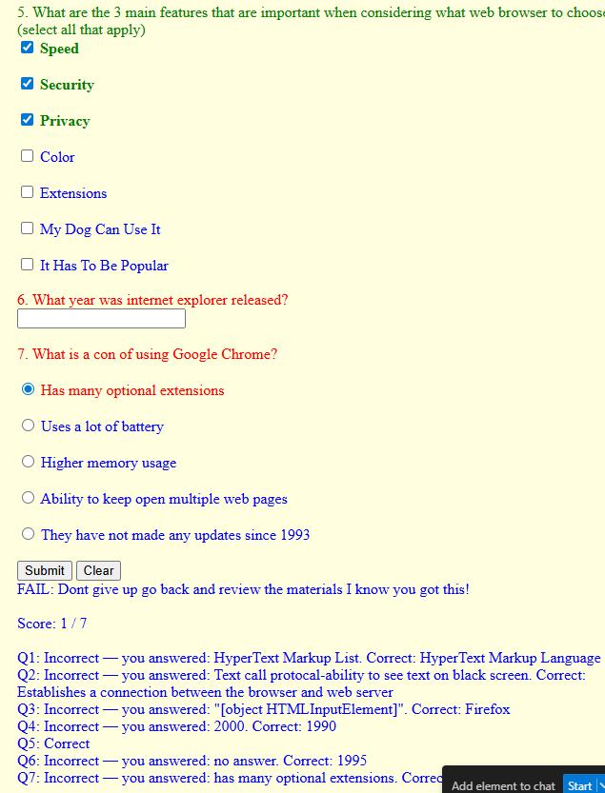

- The choice button I chose to use is a simple clear button that gives user ability to retake the quiz.


In conclusion this milestone, I believe, was a bit more difficult than the last one and did more research and learned new skills but it was a great way to enhance my skills. It was interesting to see firsthand all the different things to think about and possible different options and ways to implement actions and events. I will keep on improving the data and flow as we go into our next milestone.

Hope you like it!

